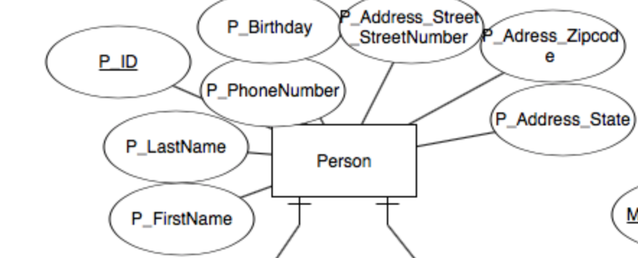

The First entity that I have is named person. The Person entity holds basic information about people who interact or are a part of the church.

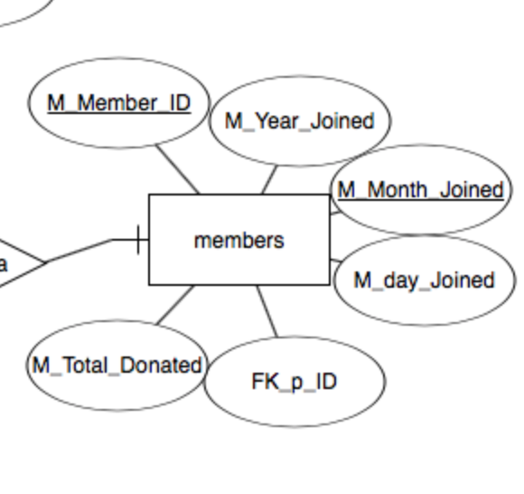

The second entity is named members and give basic information about church members and is related to the person entity through the foreign key p_ID.

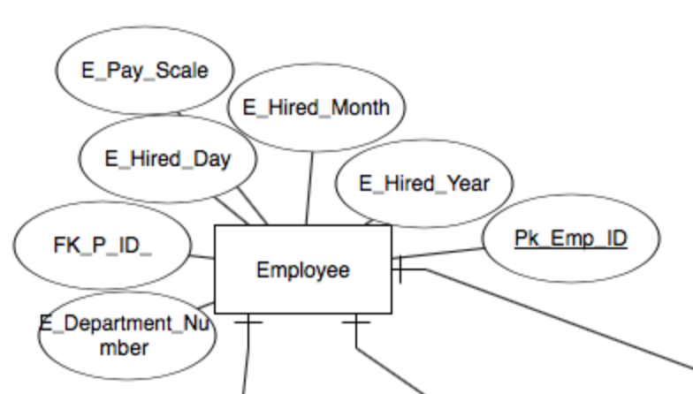

The third entity is named employee. Employee gives information regarding employee data. Employee is related to person through the foreign key P_ID

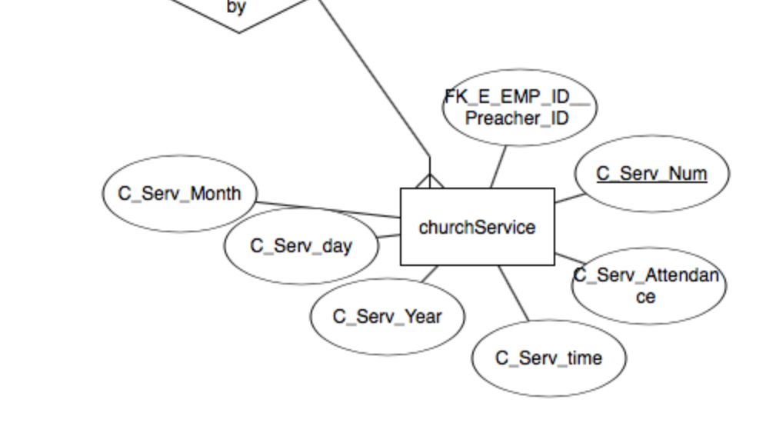

The next entity is named churchService. churchService gives information regarding individual church services. It is linked to employee through the foreign key EMP_ID. This entity is likely for churches who record services, or want additional statistics of church attendance throughout the year.

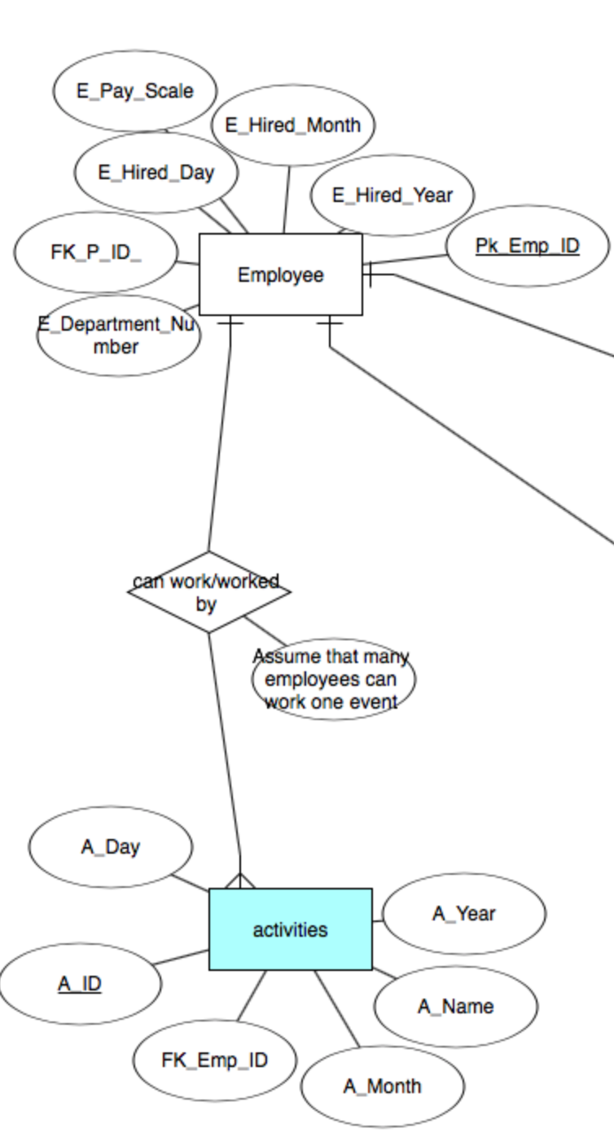

The attribute attached to the relationship is only a note/assumption and not actually a attribute. Assumption: 1) Many employees can work one event.

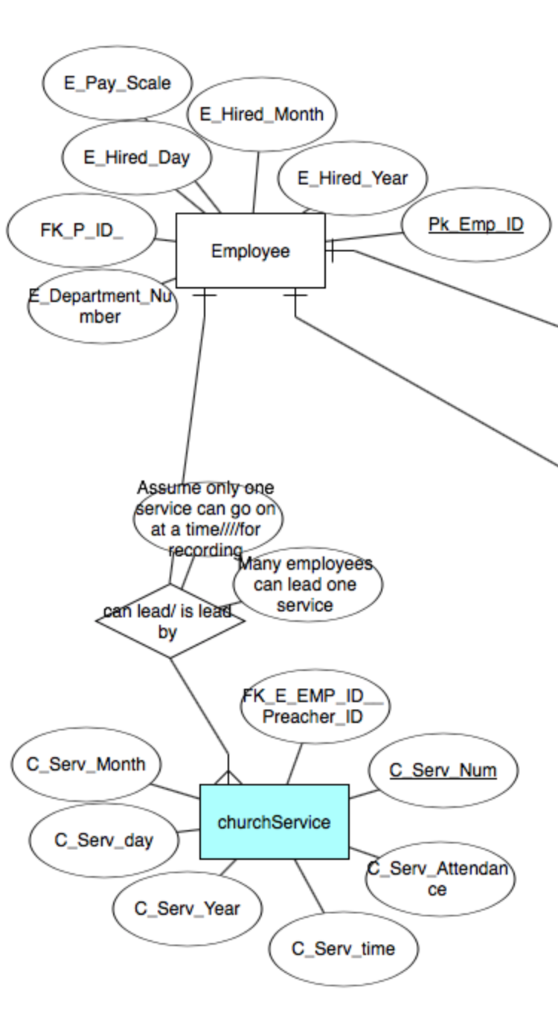

The attribute attached to the relationship is only a note/assumption and not actually a attribute. Assumptions: 1) assume that only one service can go on at a time. 2) assume many employees can lead one service ie lead pastor, worship pastor, etc.

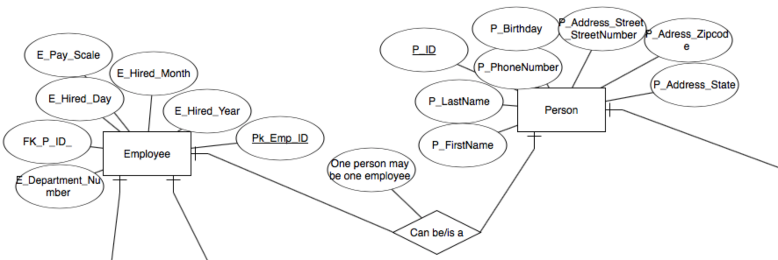

The attribute attached to the relationship is only a note/assumption and not actually a attribute. Assumptions: 1) assume that one person may only be one employee.

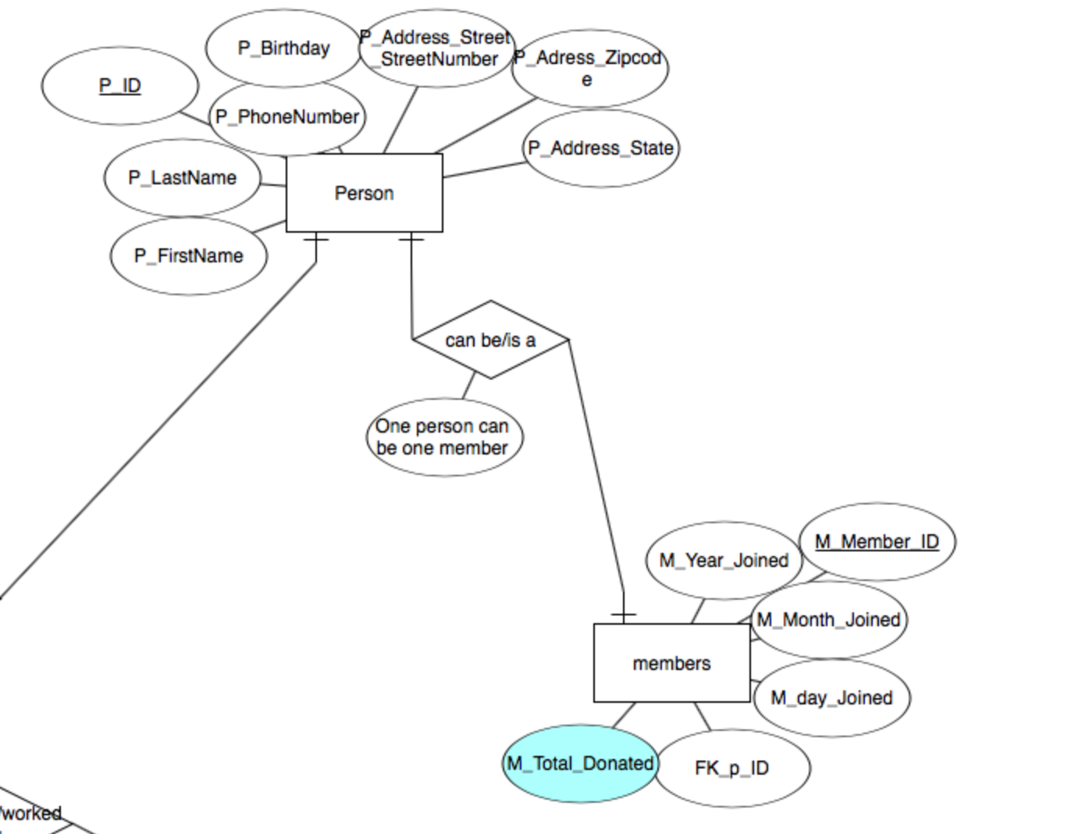

The attribute attached to the relationship is only a note/assumption and not actually a attribute. Assumptions: assume that one person can be only one registered member

